Project Overview

This project aims to create a new and improved Journey Planner for the South Yorkshire Buses company.

Glossary of terms

**What is a journey**

The act of travelling from one place to another.

Product requirements

* Create an account for a new user.
* Search route options from point A to point B.
* Visualise routes and bus stops on a map.
* Search and buy tickets.
* Check bus times and stations.
* Contact information.
* Visualise routes for different modes of transport (when a bus is not available).

Project organisation and responsibilities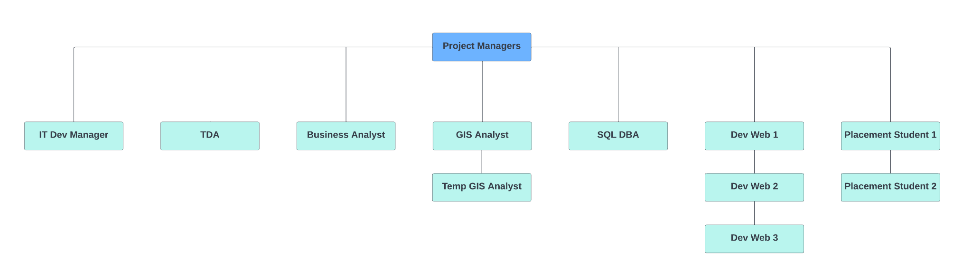

Quality requirements 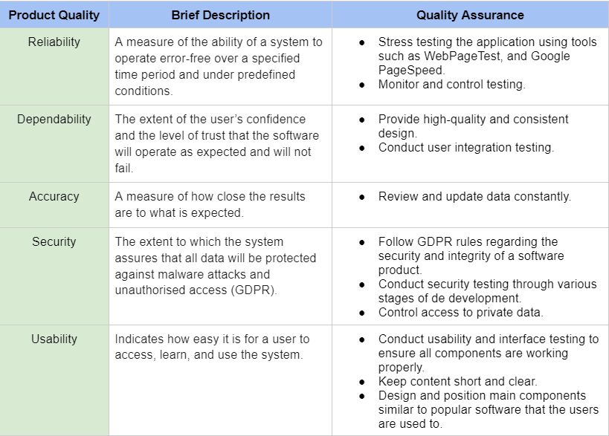

Quality management responsibilities

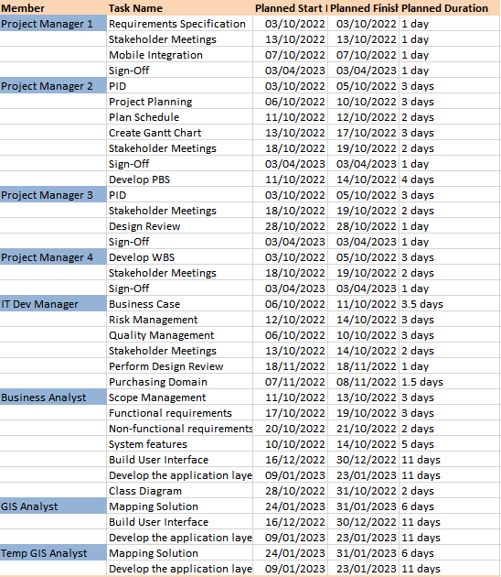

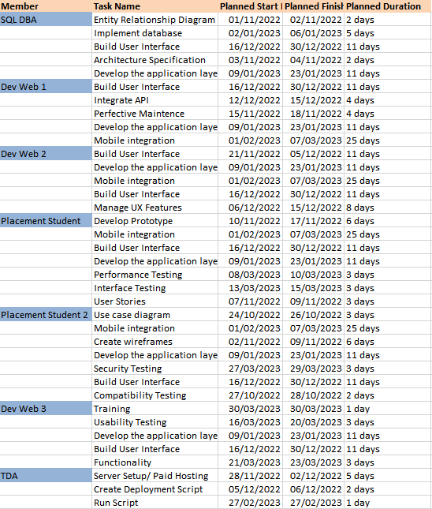

Quality control methods

What are the practices and procedures that need to be applied?

Throughout our product development, developers will be required to write unit tests for any functions/algorithms created. These tests will ensure that our code operates as expected and that no unexpected results are produced when unusual values are entered into the system. The unit tests will be run before the end of each sprint once new features have been merged into the main branch to ensure that any further changes do not negatively affect existing functionality.

All submitted pull requests will be thoroughly reviewed and tested before merging into the main branch. These will assess overall code quality, security, and functionality. If reviewers are unsatisfied with the quality of work produced by our developers, a meeting will be held. We will put a plan in place to help improve the quality of work. These plans usually involve educational courses or shadowing more experienced people.

Towards the end of development, the entire system will be subject to an in-depth series of tests to ensure that every aspect of the application is of the highest quality. The types of tests that will be conducted include:

* Functionality testing
* Usability testing
* Interface testing
* Compatibility testing
* Performance testing
* Security/penetration testing

Testing - Acceptance Tests

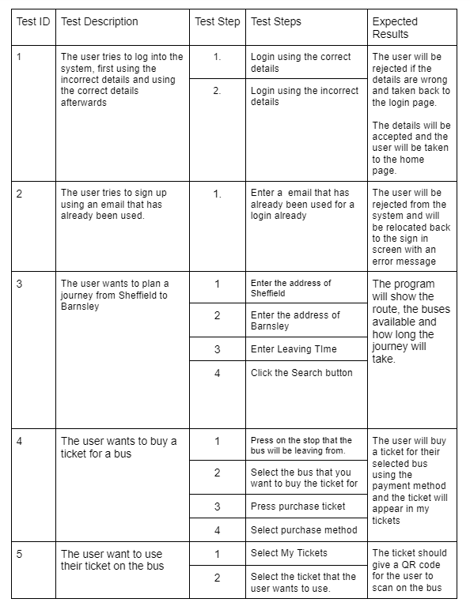

Project risks

